HEAT PAST EXAM BOOKLET

Contents

Syllabus Points 3

Heat and Temperature 1.1 4

2015 4

2018 4

2019 5

2020 6

2021 6

Specific Heat Capacity - 1.2 7

Integrated Science 2017 7

2017 7

2019 8

2020 10

Latent Heat - 1.3 12

2016 12

2018 14

2019 16

Heating and Cooling - 1.4 17

2015 17

2016 17

2017 18

2020 18

2015 SIS 19

2021 23

Conduction, Convection and Radiation 2.2-2.4 25

Integrated Science 25

2015 25

2021 25

2018 26

2016 27

2017 28

Comprehension 30

2017 30

2018 33

# Syllabus Points

# Heat and Temperature 1.1

## 2015

## 2018

## 2019

## 2020

## 2021

# Specific Heat Capacity - 1.2

## Integrated Science 2017

## 2017

## 2019

## 2020

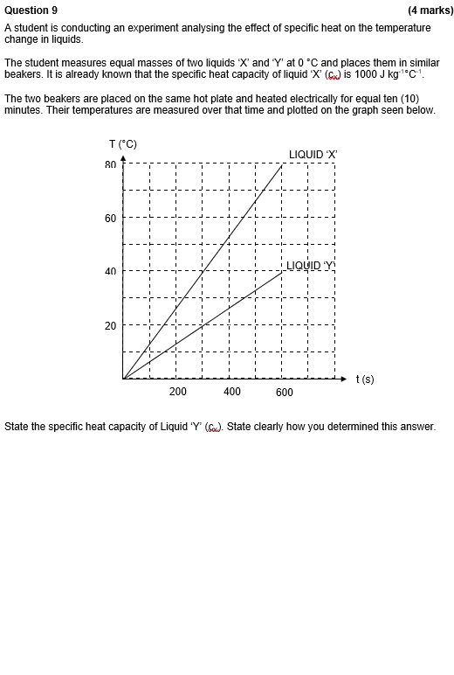

# Latent Heat - 1.3

## 2016

## 2018

## 2019

# Heating and Cooling - 1.4

## 2015

## 2016

## 2017

## 2020

## 2015 SIS

## 2021

# Conduction, Convection and Radiation 2.2-2.4

## Integrated Science

## 2015

## 2021

## 2018

## 2016

## 2017

# Comprehension

## 2017

## 2018

